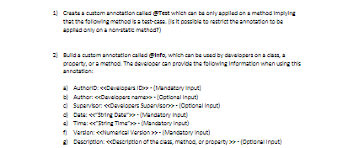

2.

package annotation;

import java.lang.annotation.Annotation;

import java.lang.annotation.ElementType;

import java.lang.annotation.Retention;

import java.lang.annotation.RetentionPolicy;

import java.lang.annotation.Target;

@Target(ElementType.TYPE)

@Retention(RetentionPolicy.RUNTIME)

@interface info{

int AuthorID();

String AuthorName() default "opttional";

String SupervisorName() default "opttional";

String Date();

String Time();

int Version();

String[] Description() default "classname,method or propertyname";

}

@info(AuthorID=123,AuthorName="abc",Date="06-11-2021",Time="12:45",Version=1)

class Employeeinfo{

String Dateofbirth;

String Department;

public Employeeinfo(String dateofbirth, String department) {

super();

Dateofbirth = dateofbirth;

Department = department;

}

}

public class EmployeeInfoAnnotation {

public static void main(String[] args) {

Employeeinfo obj =new Employeeinfo("14-04-2000","hgf");

Class c = obj.getClass();

Annotation an =c.getAnnotation(info.class);

info information = (info)an;

System.out.println(information.AuthorID());

System.out.println(information.AuthorName());

}